

Historic Bath State Historic Site
PO Box 148, Bath NC 27808
(252) 741-6030 (front desk) - (252)741-6035 (office)
bath@dncr.nc.gov

Thank you for your interest in booking an event with Historic Bath State Historic Site! Below you will find our rental fees, available locations, and frequently asked questions. If you have other questions or would like to book your event, contact us and we will work with you to reserve a date.
Your support makes our educational programming possible. Thank you!

Rental fees

Limited Rate $75.00 per hour - one location (ex. Bonner Point only)
$150.00 per hour inclusive - more than one location (ex. Bonner Point and Bonner House backyard)

Locations
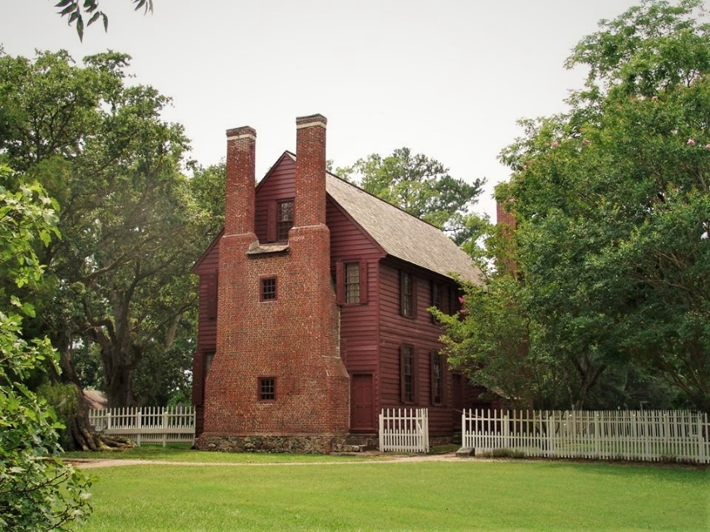
Palmer-Marsh House yard
Built in 1751, the Palmer-Marsh house and its iconic double chimney make a stunning backdrop for an event. The generous lawn can accommodate larger seating arrangements.

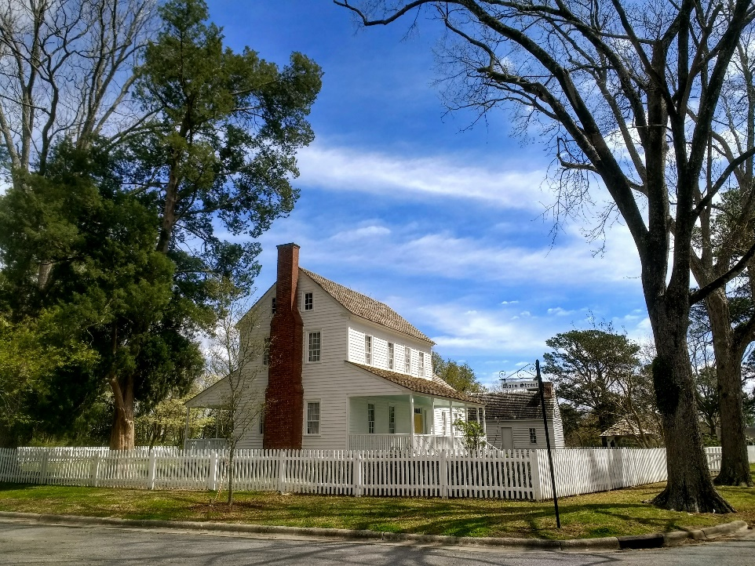
Bonner House yard
This 1830s home is perfect for an intimate ceremony or smaller reception and boasts lovely water views. The Bonner yard can also be used in conjunction with Bonner Point for a beautiful photo-op.

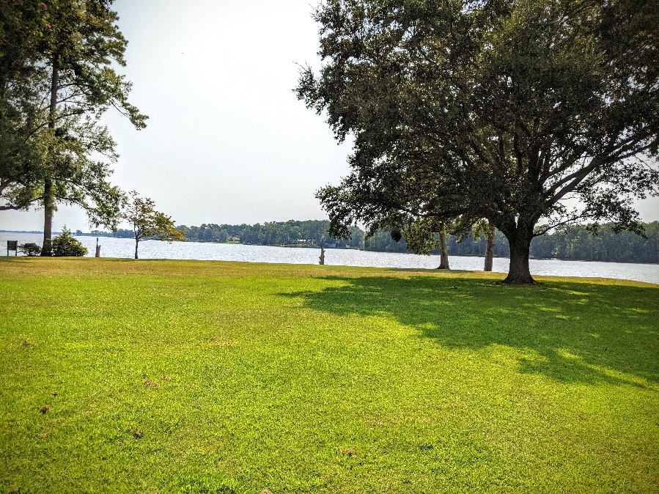
State Dock
The State Dock is perfect for a small gathering or send-off via boat. The long dock faces west for beautiful sunset views and is conveniently close to the Palmer-Marsh house.
Just keep in mind there are no electrical outlets available at the dock area.

Bonner Point
The stunning views off Bonner Point and spacious green lawn make it perfect for gatherings of any size. This is the most popular of the wedding locations.

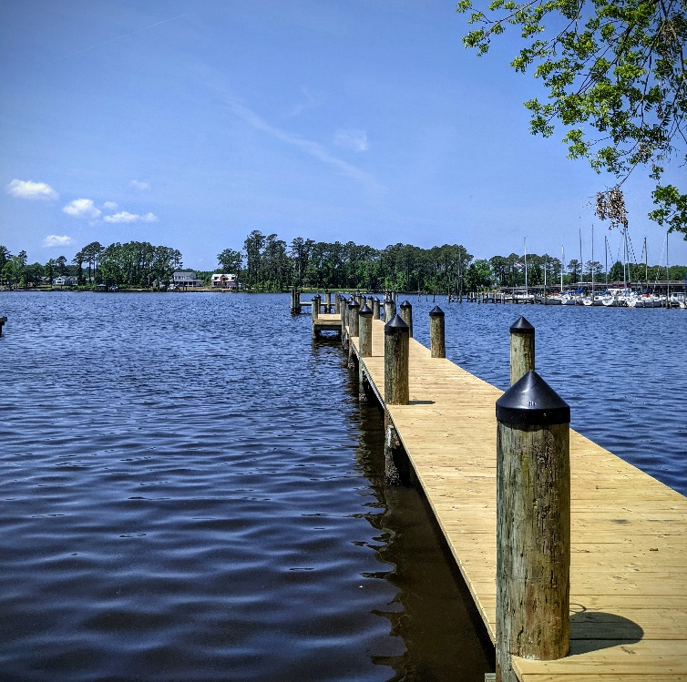

Frequently Asked Questions

How do I reserve an event location?
Please submit a Special Use Permit Request. These can be emailed to you, or you can pick up a hard copy from the site. Once we receive a request, we will issue you a permit for use of the property, at which time your deposit is due.

Tell me about my deposit?
A refundable deposit is used to hold the reservation and to cover any damages incurred. It is due upon receipt of the permit.
Deposits must be paid via cash or money order. Cash deposits must be retrieved in person, money orders can be returned via mail. Deposits not retrieved within 30 days will be forfeited (will become a donation to the historic site).

How do I pay my fees?
Rental fees may be paid with cash, money order, or check. Checks must be made out to NC Department of Natural and Cultural Resources. Fees are due 5-10 business days before the event, which will be specified on your permit.
Fees are refundable in full up to 5 business days before the event, after which they will not be refunded.

Can I change my event date?
Yes. Please speak to a staff member. If the requested date is available, we can alter your permit up to 5 business days before the event.

Can I cancel my event and get a refund?
Yes. Cancelled events will receive a full refund up to 5 business days before the event. After that period, fees for cancelled events will not be refunded.

When can I set up/take down for my event?
Set up and take down are included in your reserved time, so please select an adequate amount of time. Additional time may be arranged upon request and may impact your fees.
Part of my event will take place during operating hours (Tues-Sat, 9-5). What does this mean for my event?
If your event is scheduled during operating hours, tours may take place during your set up and take down. Tours will not be taken into the houses if an event is ongoing in the yard. Please speak with a staff person if you have questions about this.

Can I hold a rehearsal?
Yes. A one-hour rehearsal time can be scheduled at no additional charge if the space is available.

How many people can attend my event?
Some rental areas at Historic Bath can only accommodate approximately 50 people, while other can hold up to 250. Please speak to a staff member about event size and location.

Where do I/my guests park?
The site parking lot is available for events in the Palmer-Marsh house area, or as overflow parking for larger events. For events taking place near Bonner House/Bonner Point the maintenance yard is available. Request more information from a staff member.

Is there power available?
Yes, most areas have access to power. Please confirm this with a staff member. Renters must supply their own drop cords and equipment. Request more information from a staff member.

Are restrooms available?
No restrooms are available in the Bonner House/Bonner Point. You may rent Port-o-johns that may be placed behind the Bonner Cottage.
For weddings taking place in the Palmer-Marsh area, port-o-johns may be placed near the Administration building.
During operating hours, the Exhibit Center building restrooms are available.

How early/late can my wedding take place?
Events must take place between 8am and 10pm. Takedown for an event may be arranged for the following day if necessary – please speak to a staff person about this option.

Can I serve alcohol at my event?
Renters may serve alcohol if they have an ABC permit or if their caterer has a permit.

Is there an indoor option or rain plan location?
The interiors of the buildings are not available for weddings.

Are tables/chairs/linens available for rent?
Not at this time.

Thank you for your interest in booking Historic Bath State Historic Site for your event!

Historic Bath State Historic Site
PO Box 148, Bath NC 27808
(252) 741-6030 (front desk) - (252)741-6035 (office)
bath@dncr.nc.gov

